[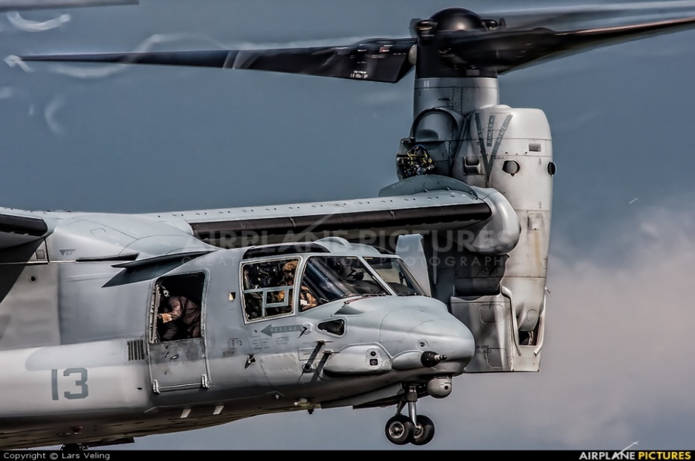](https://www.google.com/url?sa=i&rct=j&q=&esrc=s&source=images&cd=&cad=rja&uact=8&ved=2ahUKEwiB6pvqj_LcAhXC1lMKHRJUCDcQjRx6BAgBEAU&url=https://www.airplane-pictures.net/type.php?p%3D3612&psig=AOvVaw0Lrlk6wKkLQUI3b4XON7wA&ust=1534527843158340)

**MIL-STD-1553**

**Our MIL-STD-1553 Databus Network Tester will detect, and isolate wiring faults on platforms with a databus harness system. Part No. SW29716**

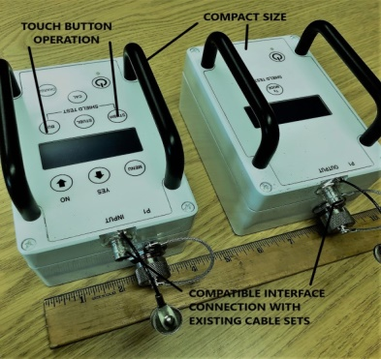

***FEATURES***

* The enclosure, display, keyboard and electrical interfaces have been designed to meet the requirements of CS235
* Interface connections replicate the USN’s incumbent DBNT (S2476N) allowing continued use of all existing interface cable sets.
* The TXU electronics provide a composite signal comprising a high frequency component for insertion loss measurement and wiring fault detection with periodic bursts of a lower frequency component for wiring polarity detection.
* The LCD indicates battery charge state, and four lines, 20 characters/line, of text providing test and operator information.
* The RXU electronics controls mode of operation and the LCD indicates battery charge state, and four lines, 20 characters/line, of text providing test and operator information.
* The PCB’s and electronic components employ latest generation surface mount technology ensuring reliability and security of supply for many years.
* The TXU and RXU are powered by internal battery packs with nominal voltage of 10.8 VDC , and a minimum charge life of 12 hours under test conditions. . A Universal AC power supply charging both units simultaneously is supplied. The batteries can be charged from any 18 to 36 VDC utility or from any aircraft 24VDC utility supply via a platform specific power cable. Charging is inhibited when connected to an aircraft utility power supply.

***BENEFITS***

* ENABLES PREVENTATIVE MAINTENANCE

* REDUCES “NO FAULT FOUND” RATES

* ISOLATES COMMON WIRING FAULTS

* TESTS WITHOUT MAIN BUS DISCONNECT

* USE ON ANY MIL-STD-1553 PLATFORM

* SEPARATE TRANSMITTER, AND RECEIVER FOR REMOTE OPERATION

* WILL INTERFACE WITH EXISTING CABLE SETS

* CAN BE SUPPLIED WITH INTERFACE CABLE KITS IF REQUIRED

* USABLE WITH SINGLE OPERATIVE

* LIGHT WEIGHT, SMALL SIZE, PORTABLE

* DAILY SET UP / CALIBRATION PAD INCLUDED

* CHARGER WITH LEADS SET INCLUDED

***SOUTHWEST INTER CONNECT INC.***

**9221 Live Oak Lane, Unit 1, Fort Worth, TX 76179-4063**

**Tel: 682/385-9751, fax: 817/385-9752, cell: 817/994-8033**

**cage code 00HC0**

***SPECIFICATIONS* Part No. SW29716**

**Accuracy and Measurement Range**

1. Return Loss Measurement; Range +15dB to -65dB to a resolution of 0.01dB.

2. Cable Fault Detection:

• Open Circuit of one or more signal wires.

• Short Circuit between signal wires.

• Cross-Over (reverse polarity of signal wires).

• Short Circuits between either signal wire and shield on the main bus.

• Short Circuit to shield on stubs.

**\*** Missing or faulty bus terminator.

**\***Insertion Loss Measurement;

Range +15dB to -65dB between any two stubs to a resolution of 0.01dB.

**The SW29716 DBNT has been designed to meet the following requirements:**

* **Temperature and humidity**

Operating temperature – 40 °C to + 55 °C up to relative humidity of 95%.

Non-operating temperature - 51 ° C TO + 71 ° C when tested in accordance with

MIL-PRF-28800F Para 4.5.5.1 & 4.5.5.1.1.

* **Altitude**

15,000 ft when tested in accordance with MIL-PRF-28800F Para. 4.5.5.2.

* **Shock and Vibration**

Sinusoidal vibration from 5 to 55 Hz at g levels up to 3 g when tested in accordance with MIL-PRF-28800F Para 4.5.5.3.2 Class 1.

Loose Cargo Bounce Vibration Test consisting of 1 inch double amplitude displacement when tested in accordance with MIL-PRF-28800F Para 4.5.5.3.3.

Shock, transit drops of 18 inches in accordance with MIL-PRF-28800F, Para 4.5.5.4.2 Class 1.

Shock, bench handling as specified in MIL-PRF-28800, Para 4.5.5.4.3.

* **Water Resistance**

Exposure to a rain spray of 4.3 gal/hr/ft2 when tested in accordance with MILPRF-28800F Para 4.5.5.5 as per Table 5.

* **Salt atmosphere, exposure, and enclosure**

Constantly wetted with a 5, +/-1 % salt solution and a 48 hour drying period in a standard ambient atmosphere when tested in accordance with MIL-PRF-28800F Para 4.5.6.2.

* **Fungus Resistance**

The DBNT shall meet the fungus resistance tests as specified in MIL-PRF-28800F, Para. 4.5.6.1.

* **Explosive atmosphere**

The operation of the DBNT shall not cause ignition of an ambient-explosive gaseous mixture with air when tested in accordance with MIL-PRF-28800 Para. 4.5.6.3 Class 1.

* **Solar Radiation**

The DBNT shall meet the applicable requirements after exposure to solar radiation when tested in accordance with MIL-PRF-28800F Para. 4.5.6.8 Class 1.

* **Magnetic environment, DC field**

The DBNT shall meet the applicable requirements of MIL-PRF-28800F Para. 4.5.6.6. Field intensity: 20 (H)Oersteds.

* **EMC**

EMC control to MIL-PRF-28800F, Table 6 when tested in accordance with Para. 4.5.6.5.

* **Electromagnetic radiation**

The DBNT shall meet the applicable requirements of MIL-STD-461E.

* **Conducted and radiated emission limits**

The conducted and radiated emission limits of MIL-STD-461E, Section 5**,** apply to the DBNT for the following specified tests: CE102 and RE101, and RE102, conducted and radiated susceptibility limits. The conducted and radiated susceptibility limits of MIL-STD-461E, Section 6, apply to the DBNT for the following specified tests: CS101, CS114, CS115, CS116, RS101, and RS103.